Installation and Runtime Notes

How to get my programs onto a different computer and options on how to run them

With LabVIEW installed:

While you should be able to run all of these programs without having LabVIEW installed, it might be the best option. This would give you access to the block diagrams so you could make edits. You might also need to alter the front panels for screens with different resolutions.

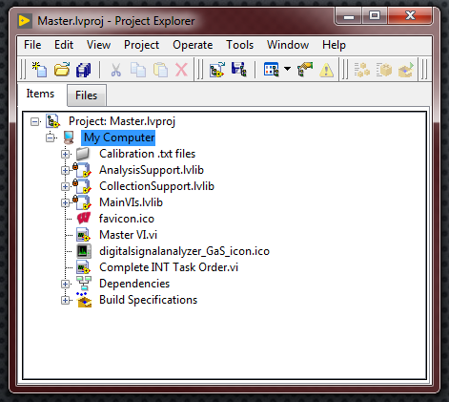

To run a program with LabVIEW installed, simply open LabVIEW then open one of the project files. Note I said PROJECT files. These end in .lvproj and contain all the Vis that go with that program. Once selected, the project explorer should load. From here, you should open the Master VI to run the program.

While you can run individual Vis, most of them are interconnected so they will not work properly if not called from their parent VI.

To copy a program onto a computer, copy the entire “Project and Vis” folder. You may need to update the file calling. You will get warnings about this.

Running from an executable:

To run a program as an executable (.EXE), the LabVIEW runtime environment will need to be installed on the computer. This is automatically installed with the full LabVIEW install. Currently all of my programs run through this method. For example, the motion W on the aerodynamics computer is a shortcut for the master aero program EXE. To run the program, simply click the shortcut.

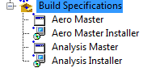To create or update executable programs, expand the ‘Build Specifications’ folder in the project explorer. From here you can double-click an EXE (marked by the window symbol) and edit its properties and build an updated version. You can also create new EXEs from here by right clicking on specifications then navigating to New 🡪 Application (EXE). You should note that, if you were to make a new program, you would have to have all your Vis organized into a Project. Stand-alone Vis cannot be converted into an application.

Installing a program:

There is an option to install programs onto a computer that does not already have the LabVIEW runtime environment. I have not quite worked out all the kinks in these installers, so there might be some issues. You are welcome to try them, just be wary. The installers work like any other installation, simply run the setup application.

To create an installer, an EXE application must already be built. Similar to building the EXE, you can select to build an installer by right clicking on ‘Build Specifications’ then navigating to New 🡪 Installer.